Function for Discrete Forces on the lumbo-sacro-pelvic region for a variable number of steps.
Implicit variables
- Maximum Impact Shock
- Minimum Impact Shock
- Load during a step.

Instantaneous load
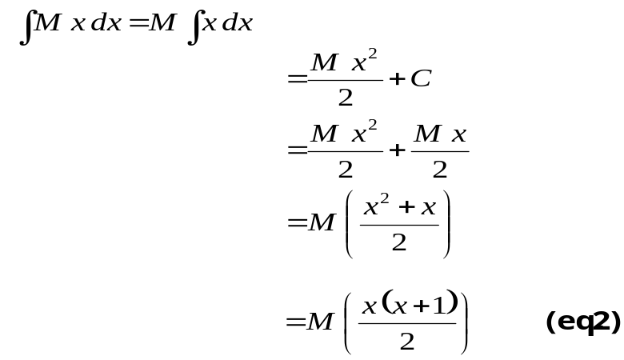 Cumulative load

I. Walking for a man 200 lbs = 890 N = 1 BW
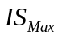 - maximum Impact Shock during a walking step, (7 BW = 6,230 N).
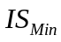 - minimum Impact Shock during a walking step. (4 BW = 3,560 N)
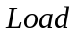- average load during a walking step. (3 BW = 2,670 N).
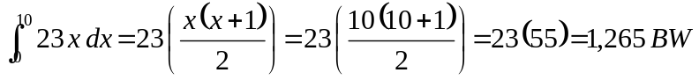

II. Skating for a man 200 lbs = 890 N = 1 BW
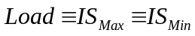 = ¼ BW = 223 N.
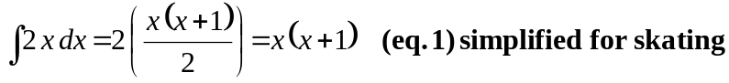
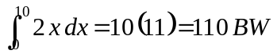

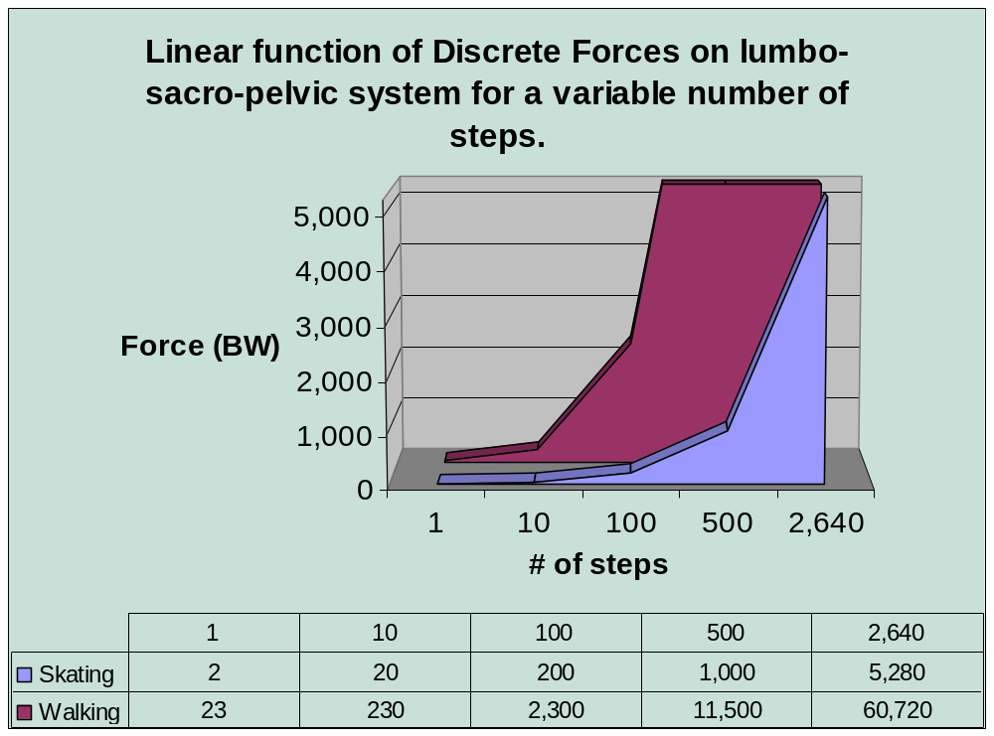
A Skating or Walking Step is equivalent to a displacement of 2 feet.

Cumulative Load
The area under the linear function is the total amount of force absorbed by the lumbo-sacro-pelvic system.
 | Cumulative Load
Steps | Skating | Walking
1 | 2 | 23
10 | 110 | 1,265
100 | 10,100 | 116,150
500 | 250,500 | 2,880,750
2,640 | 6,972,240 | 80,180,760

III. Show how this metric is relative to time
I believe that most Biomechanics metrics are relative to time, so here I am saying that a step represents a unit of time regardless of the actual time used for the locomotion.
Implicit Derivative of the Area Force Metric with respect to time:
